**FRO OTIS AUTO CONFIG UTILITY**

**Purpose:**

To automatically generate the configuration excel sheets which are the inputs to EODC Validator script on Jenkins server.

**Steps to use Auto Configuration Utility:**

1. Copy the **FRO_OTIS_EODC_AUTO_CONFIG_UTILITY.xlsm** to a local folder
2. Copy SMD of the system for which you need to create automatic configuration
3. Open **FRO_OTIS_EODC_AUTO_CONFIG_UTILITY.xlsm**
4. In “Inputs” sheet enter the systemname,config file name,SMD name & SMD sheet name
5. Click on “**Generate EODC Config**” button
6. Config excel with the timestamp will be created in the same folder. For ex: Config_TSYS_25_05_2019_07_45_21_PM

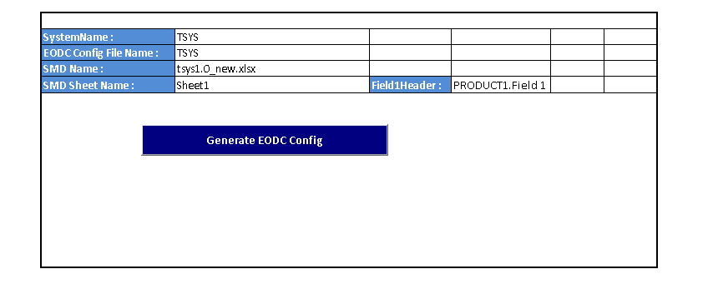

**In-Scope:**

Direct Move,Set To and ENUM functions

**Out of Scope:**

Custom rules and concatenations functions

Time taken for manually creating config : **5 hours**

Time Taken using Utility: **1 minute**